Mass Production

What were the effects of mass production on different sectors in America between 1919 and 1929?
Read through the cards, decide who is speaking and place them in the correct space on the board.

 | Baseline statement | Implication | Result | Consequence
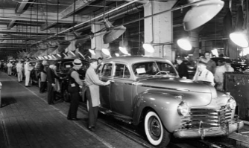  A Factory Worker | Baseline statement | Implication | Result | Consequence
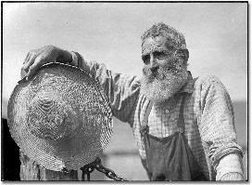  A Farmer in the USA | Baseline statement | Implication | Result | Consequence
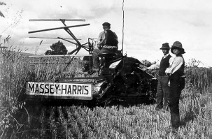  A Canadian Farmer | Baseline statement | Implication | Result | Consequence
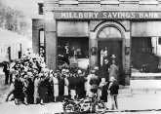  A Rural Bank | Baseline statement | Implication | Result | Consequence

